ADP470S Programming Assignment

PART A: RECURSIVE ALGORITHMS
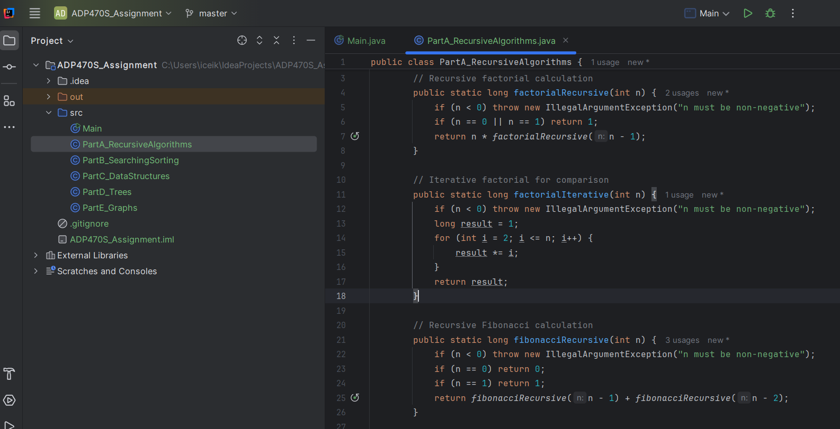
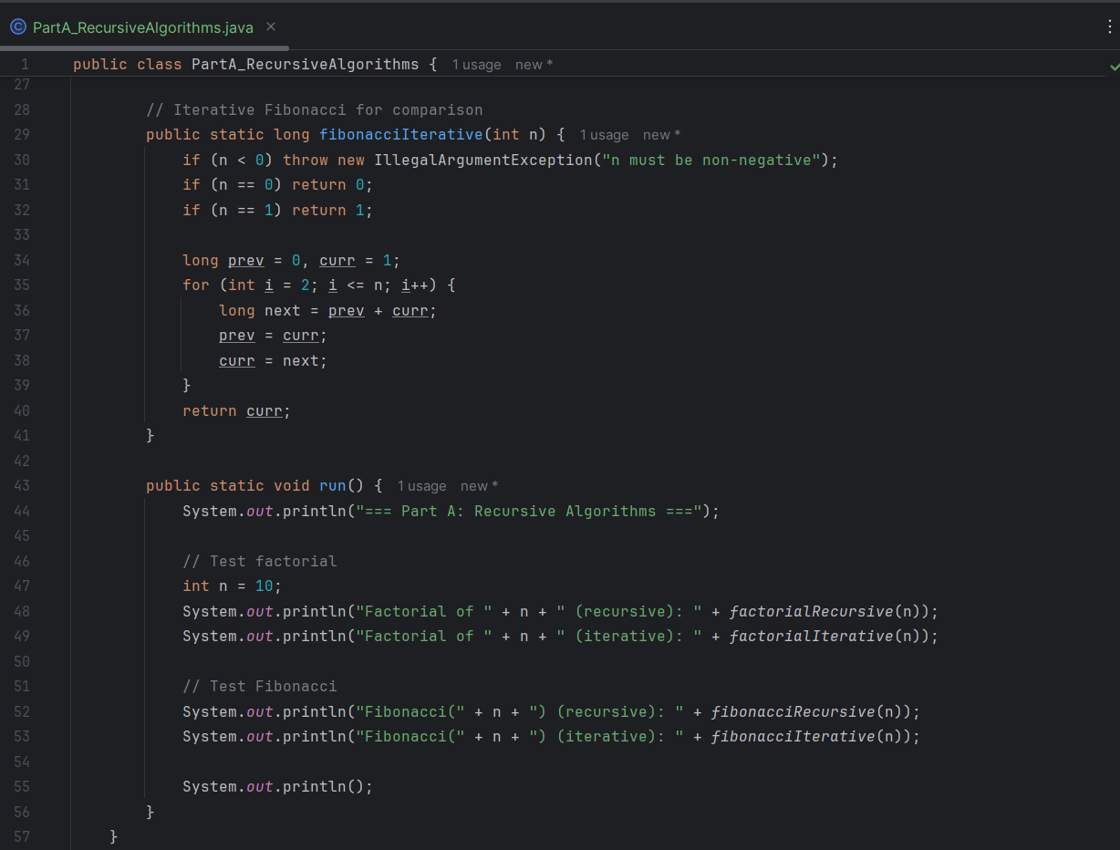
PART A: RESULTS
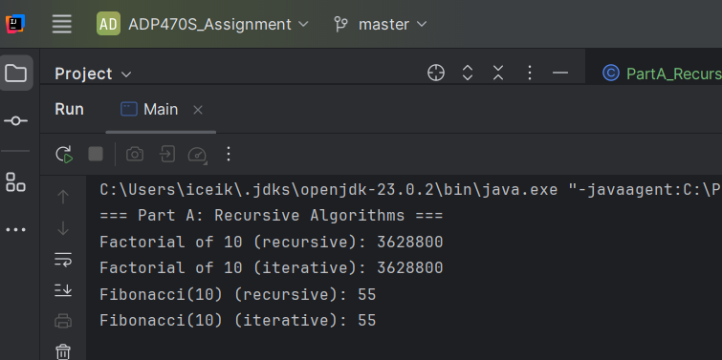

PART B: SEARCHING & SORTING ALGORITHM
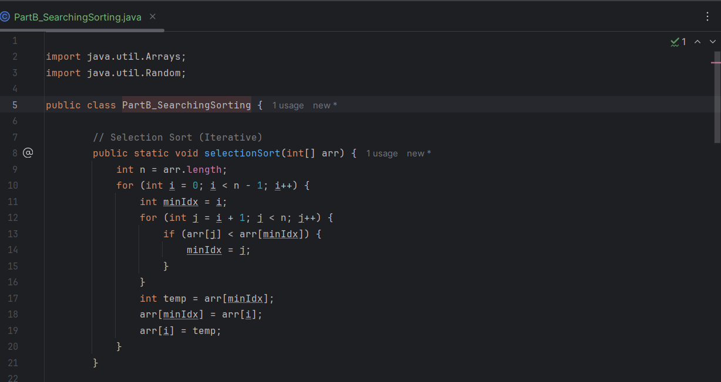
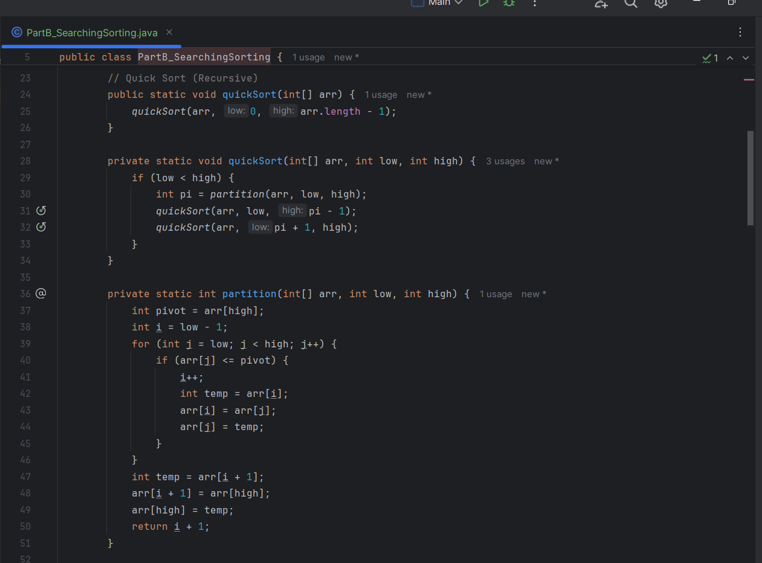
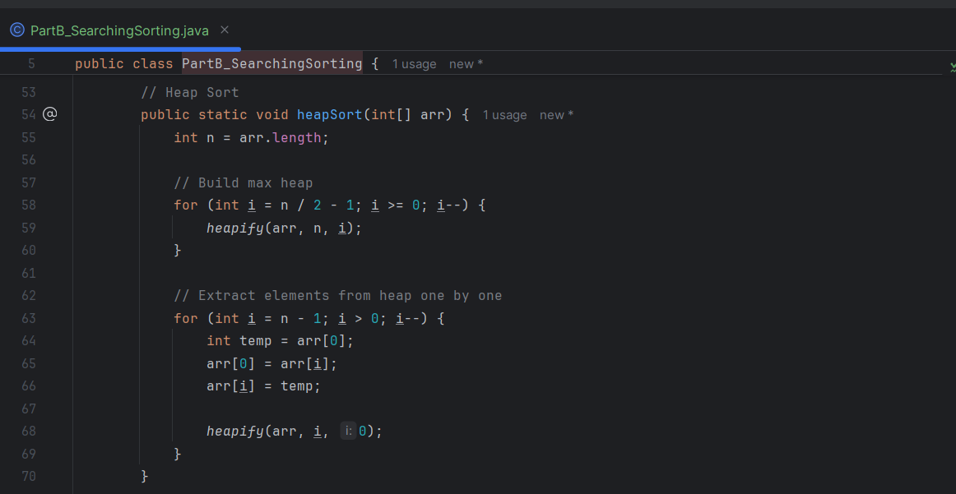
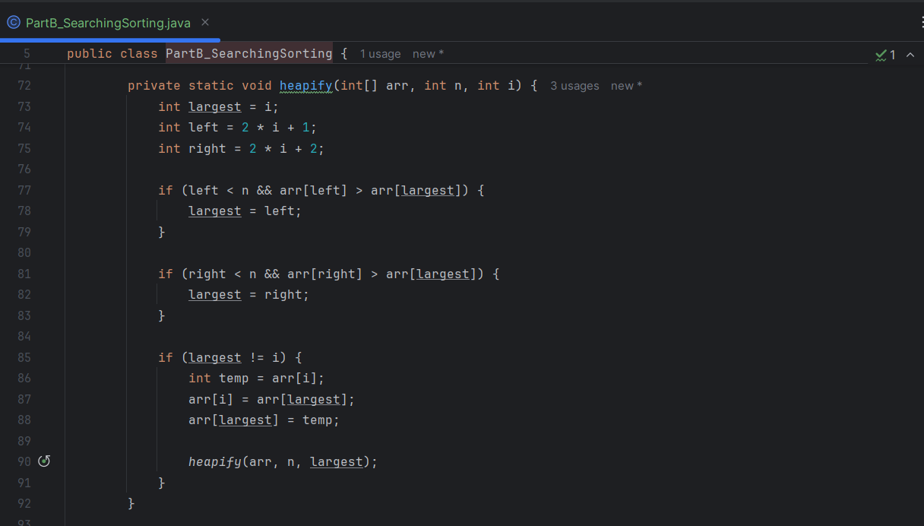
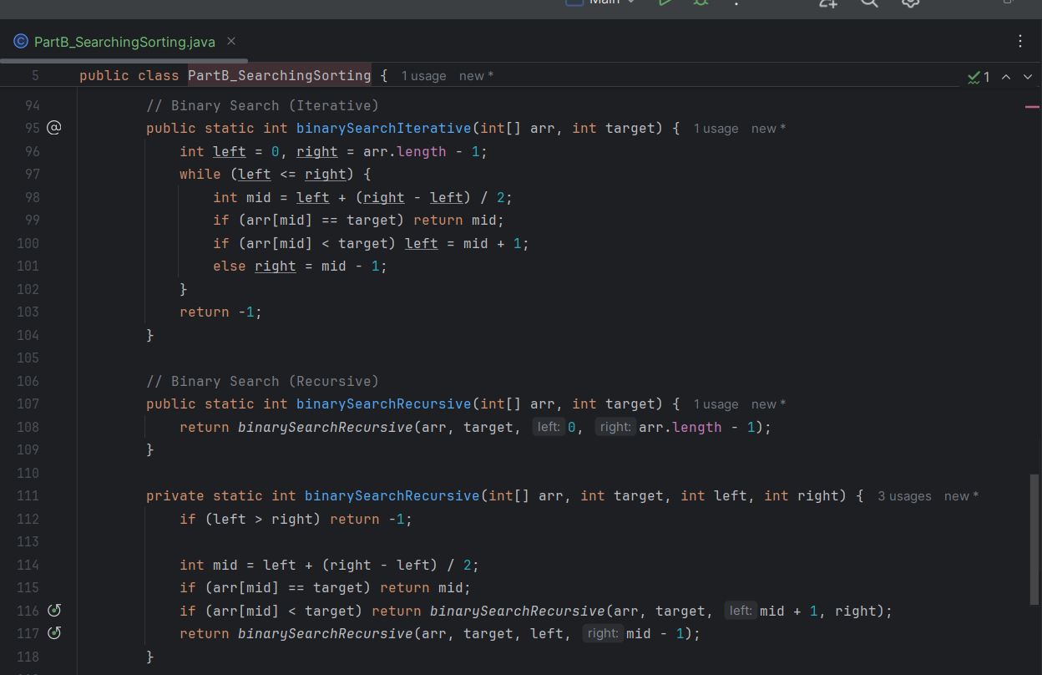
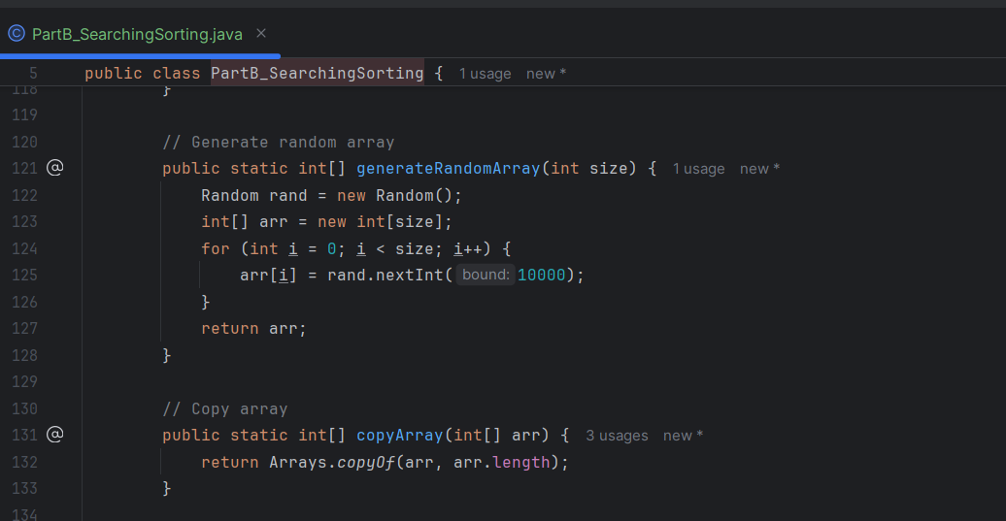
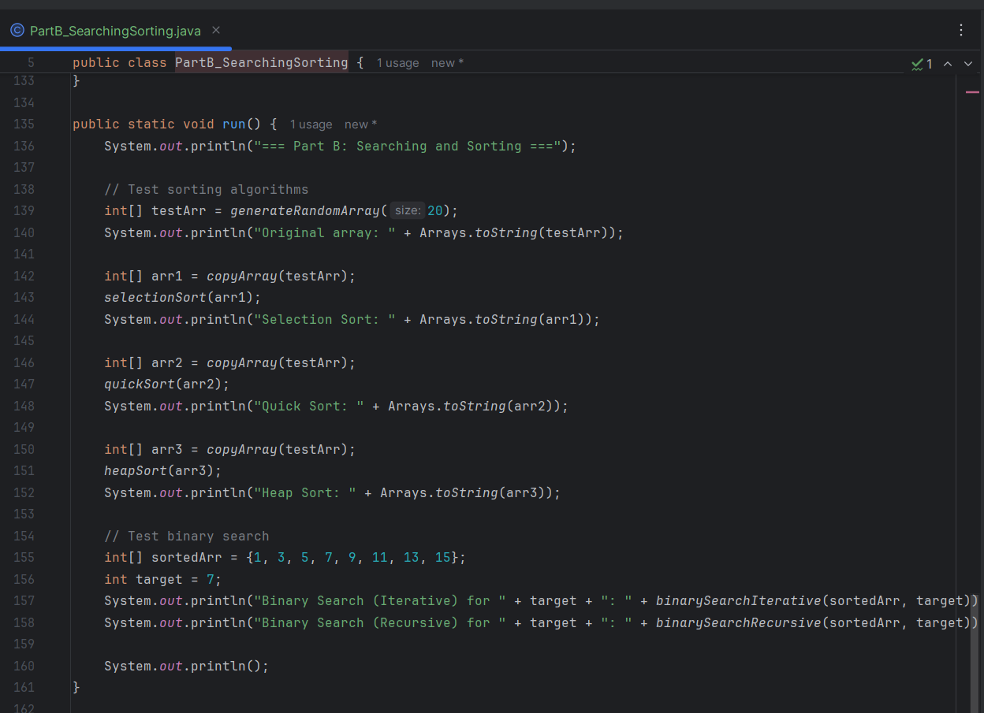

PART B: RESULTS
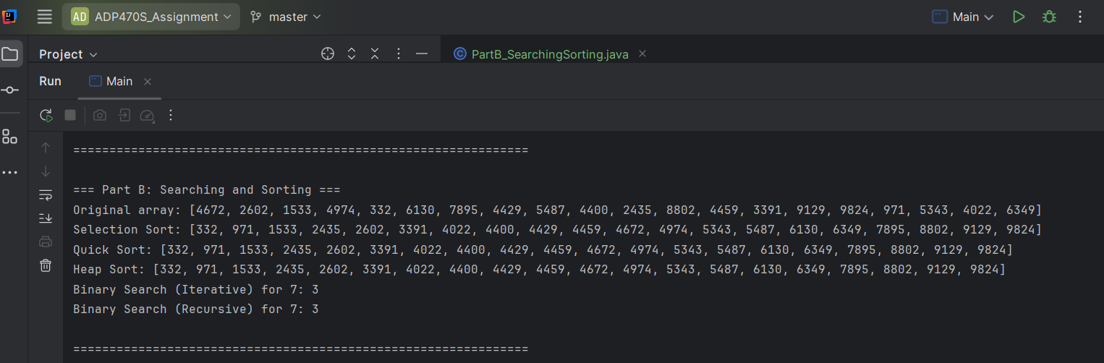

PART C: ELEMENTARY DATA STRUCTURES
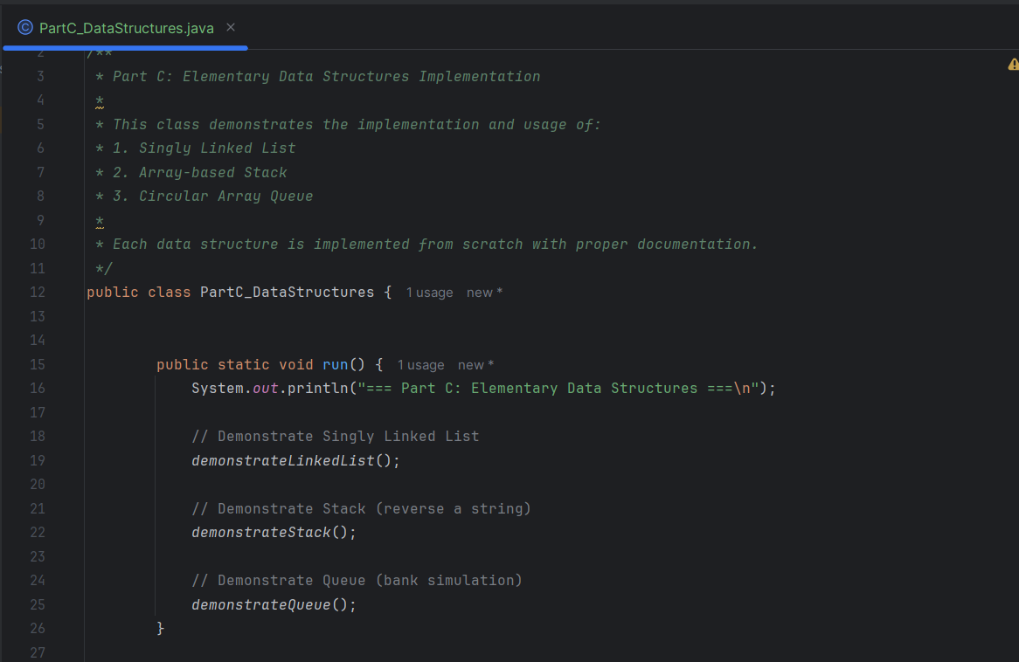
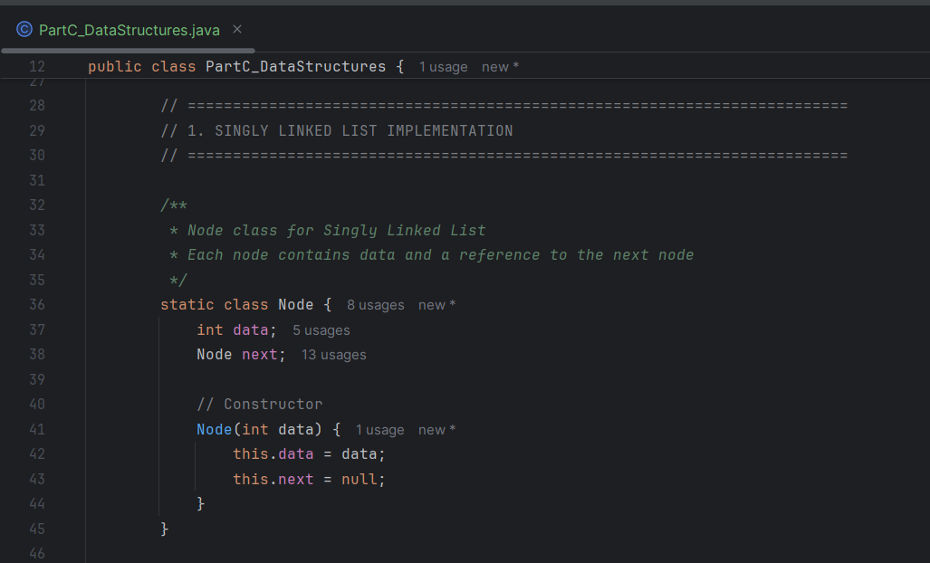
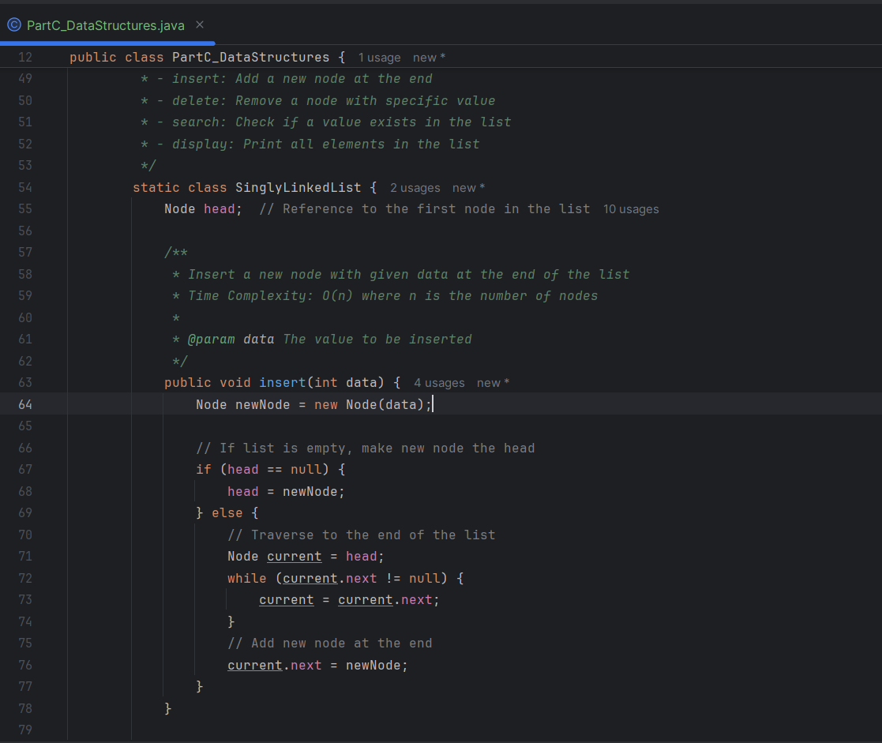
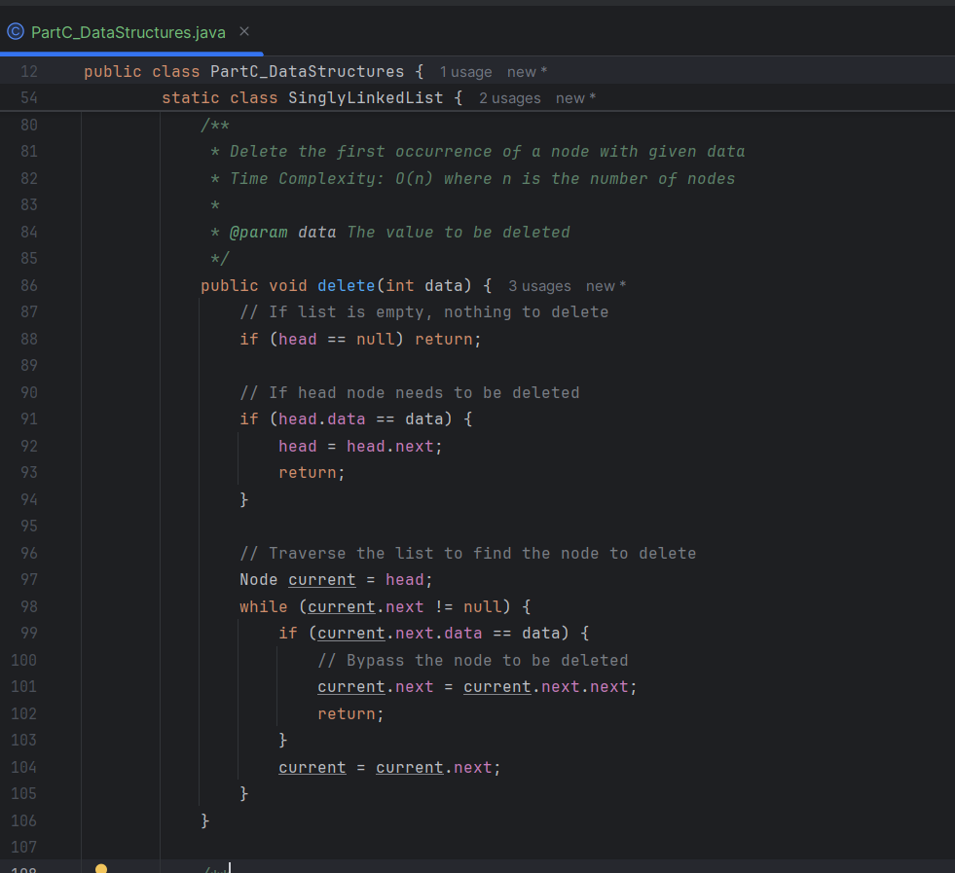
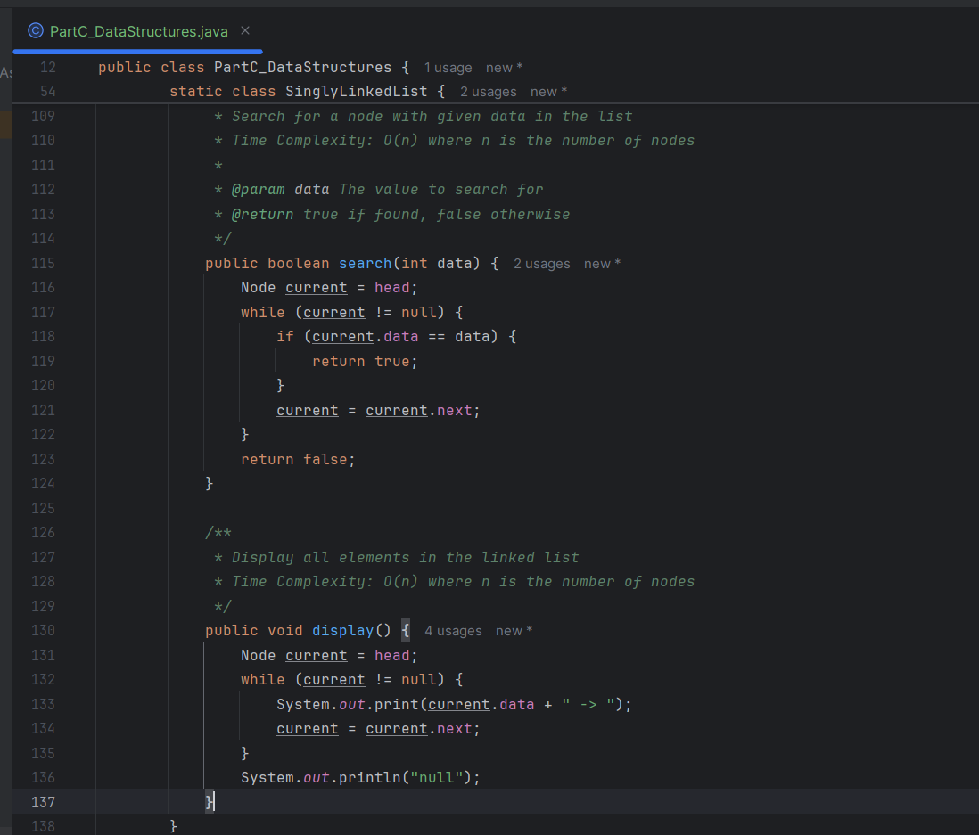
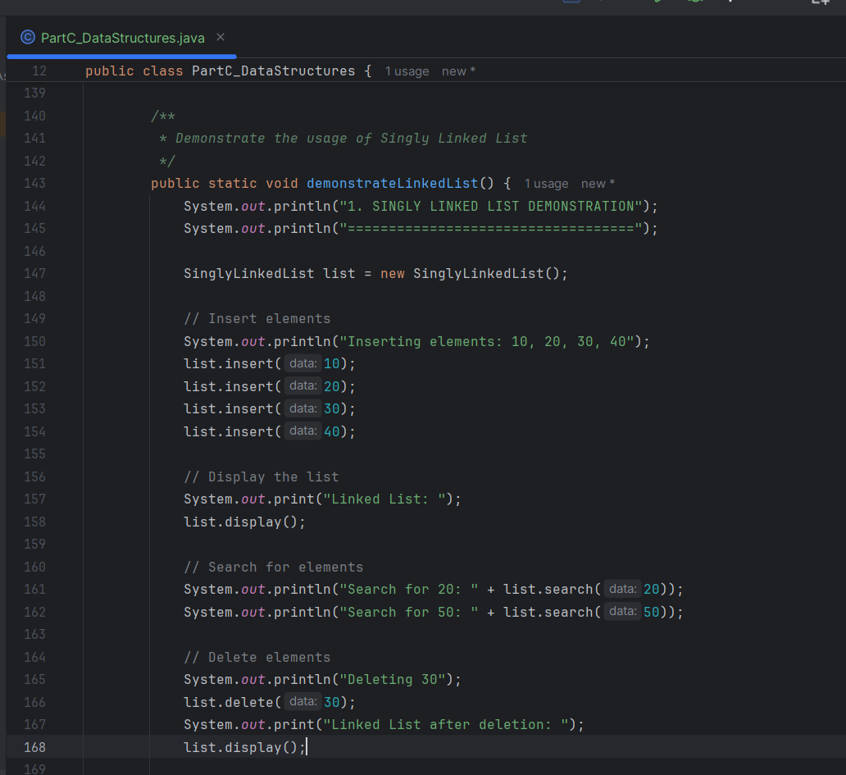
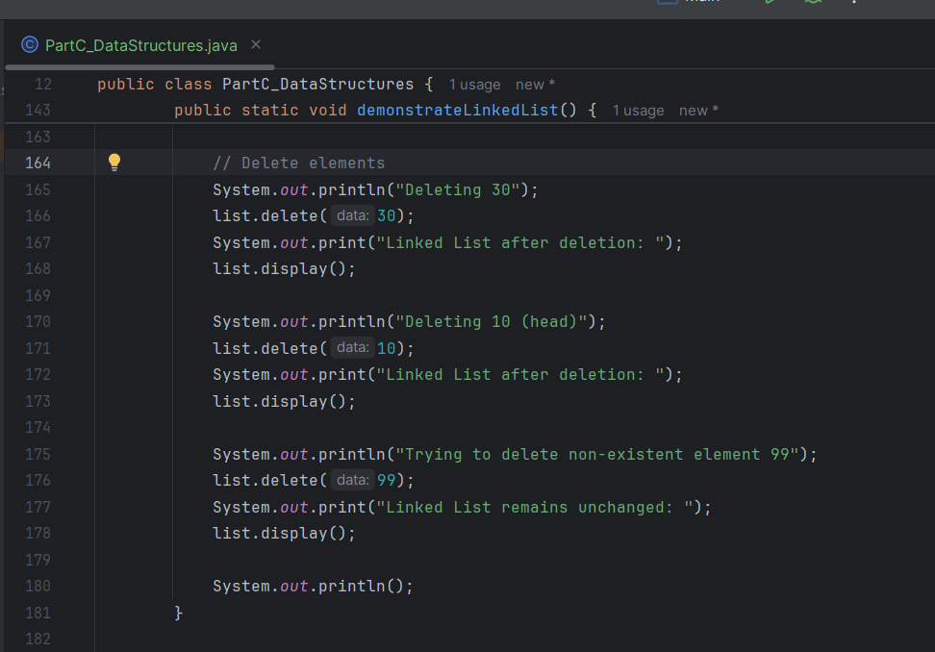
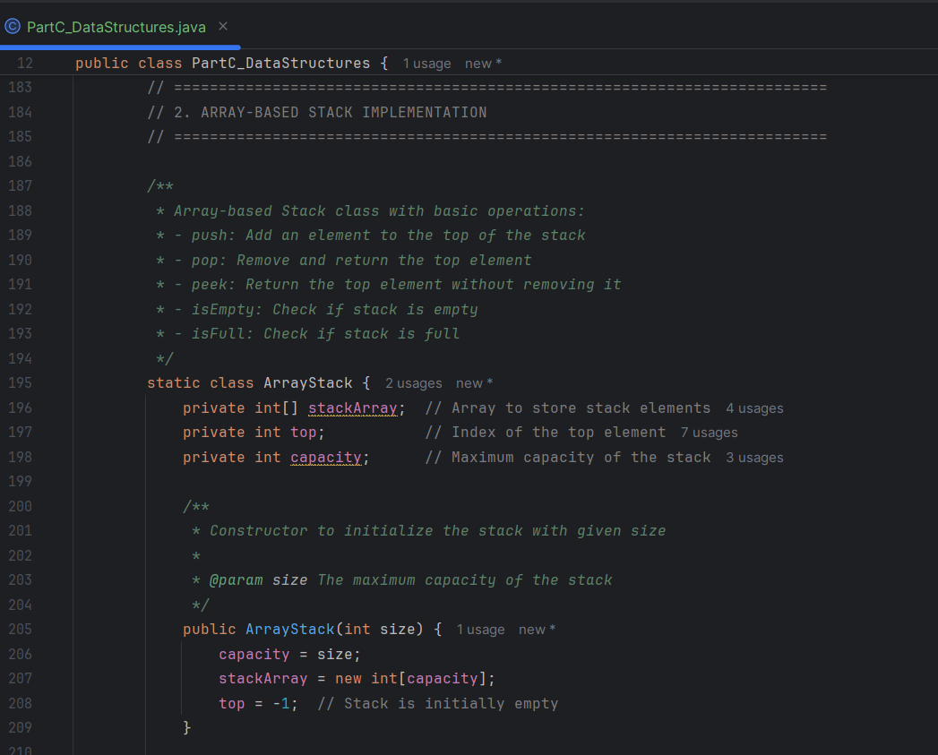
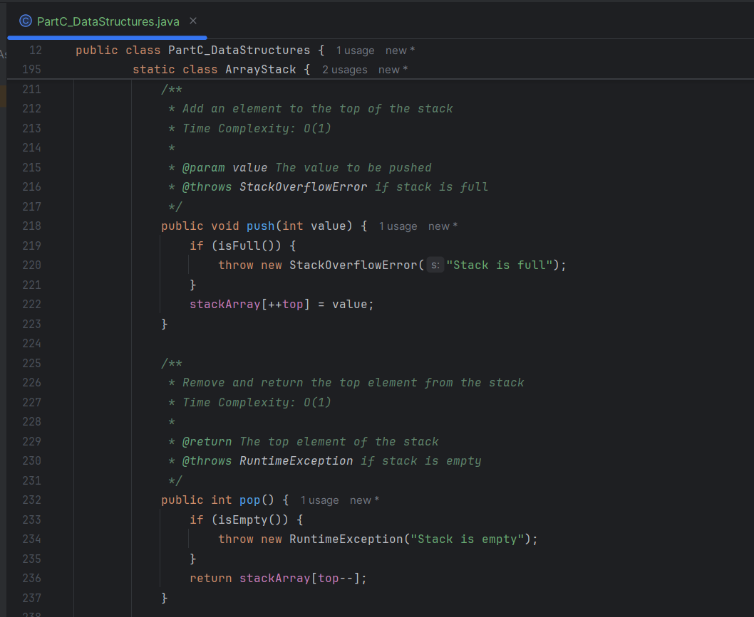
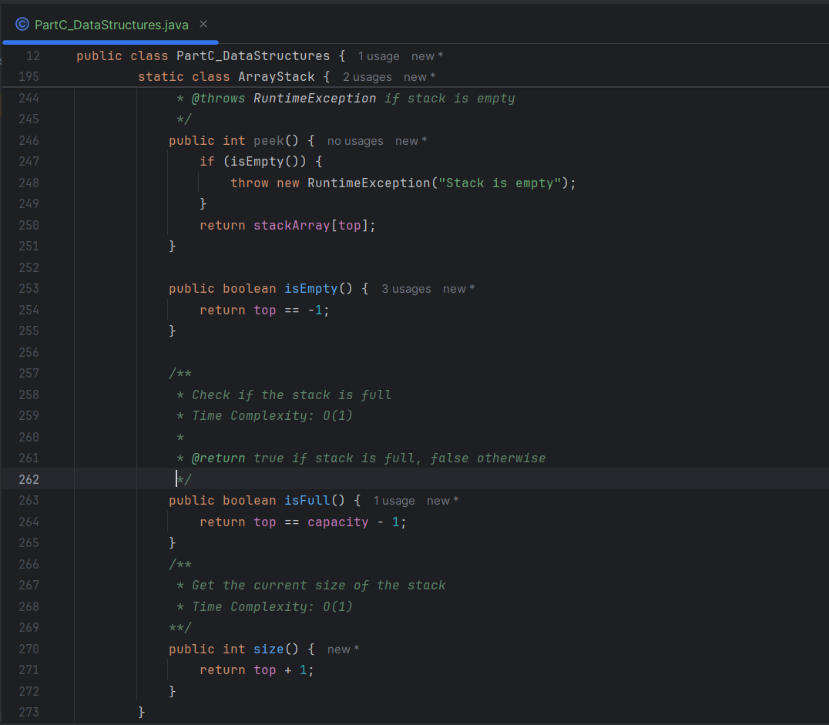
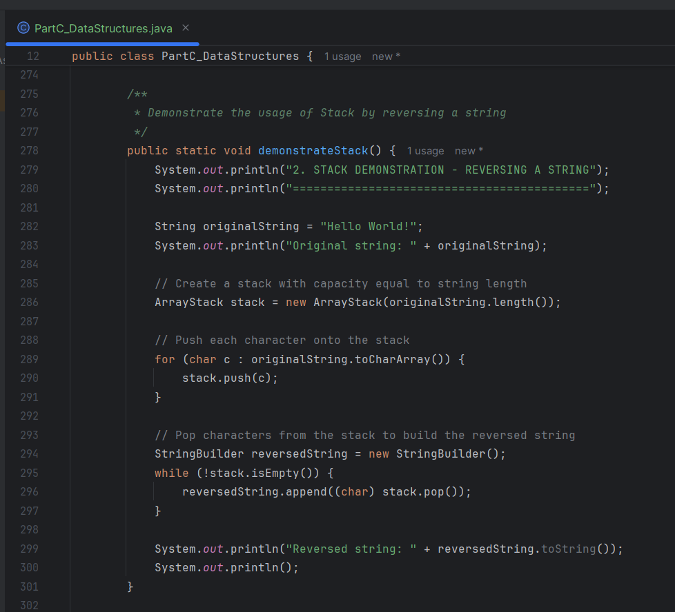
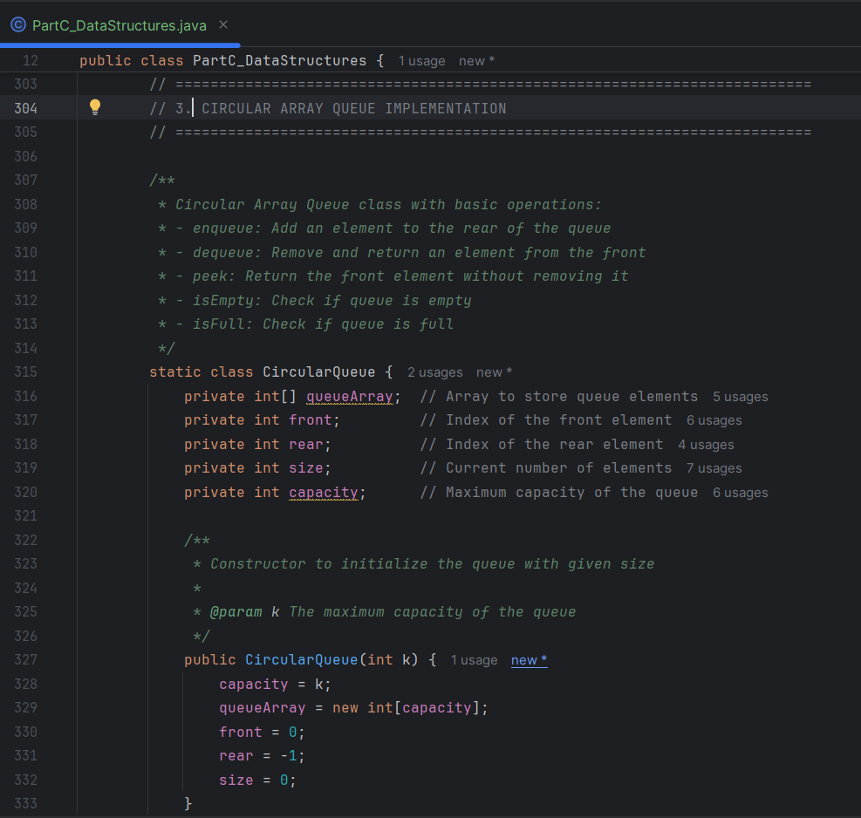
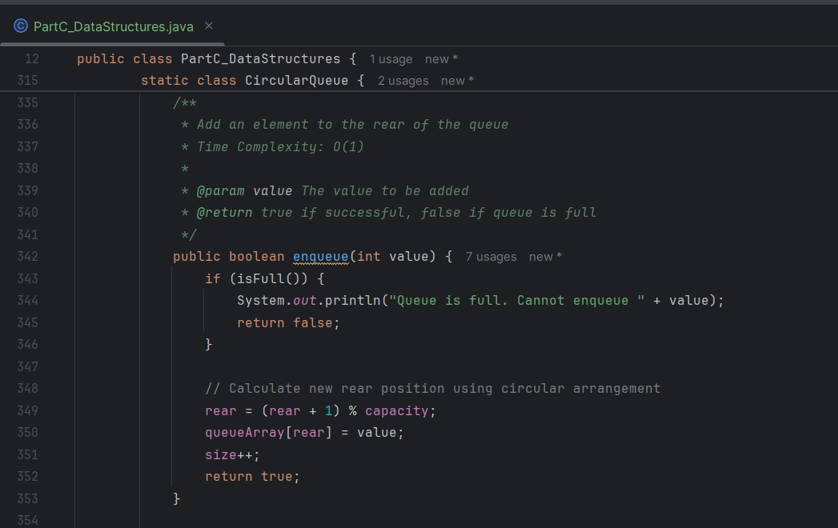
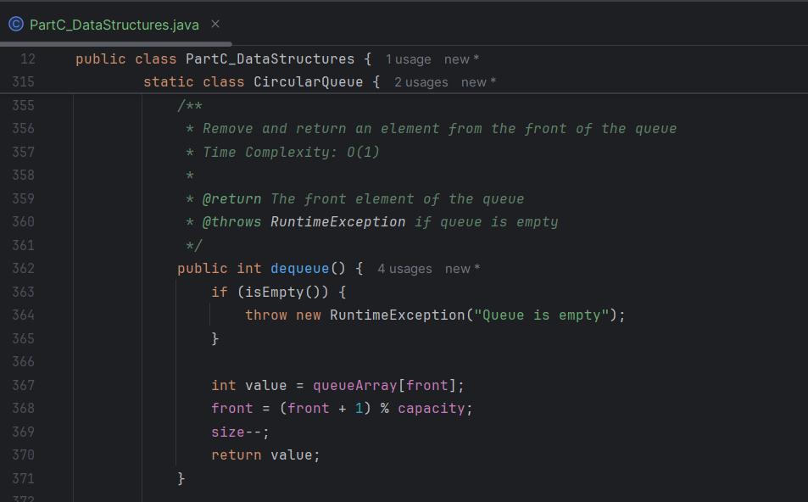
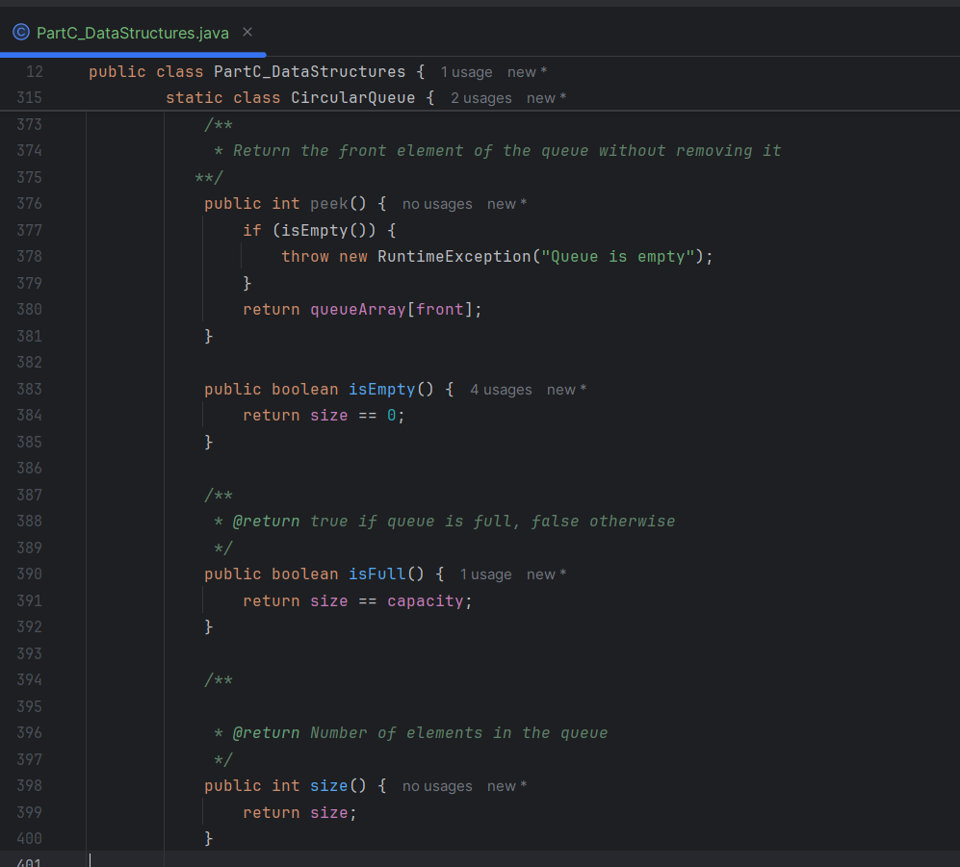
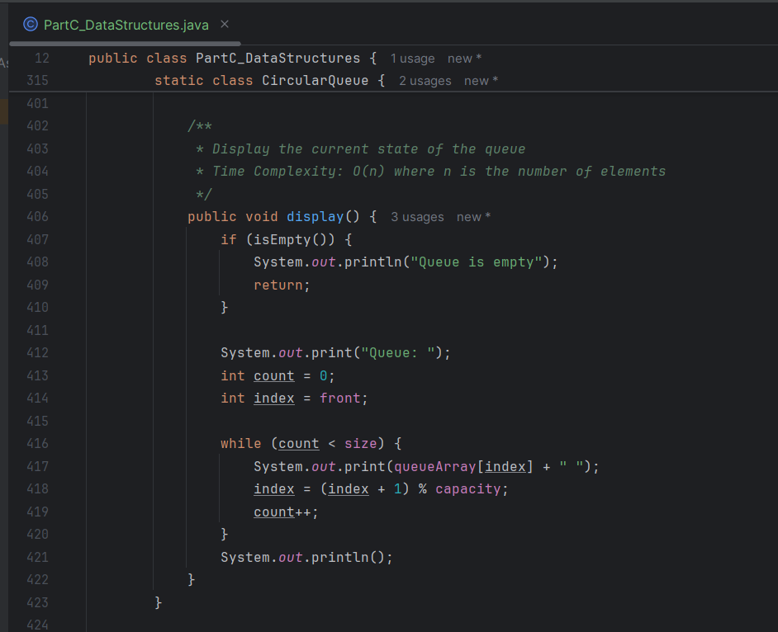
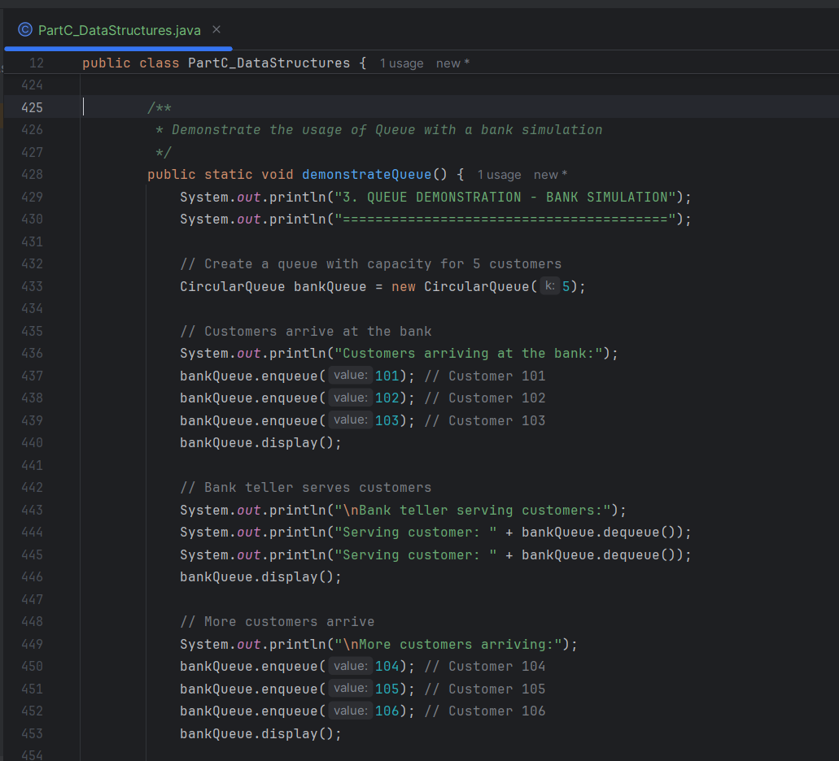
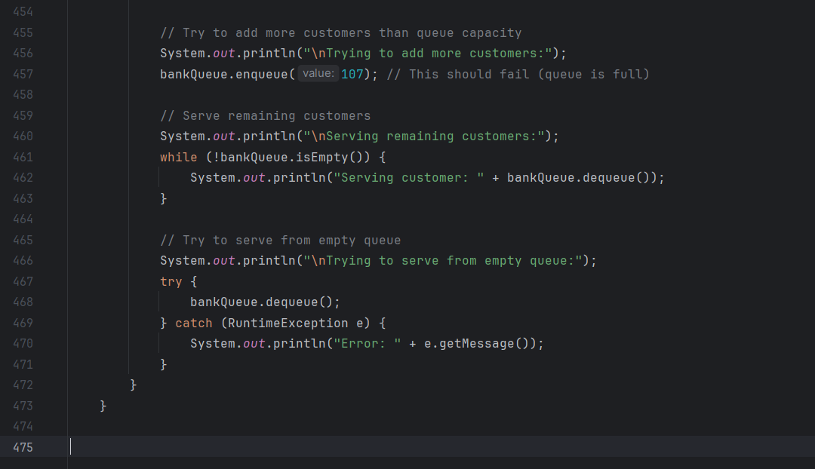
PARTC: RESULTS
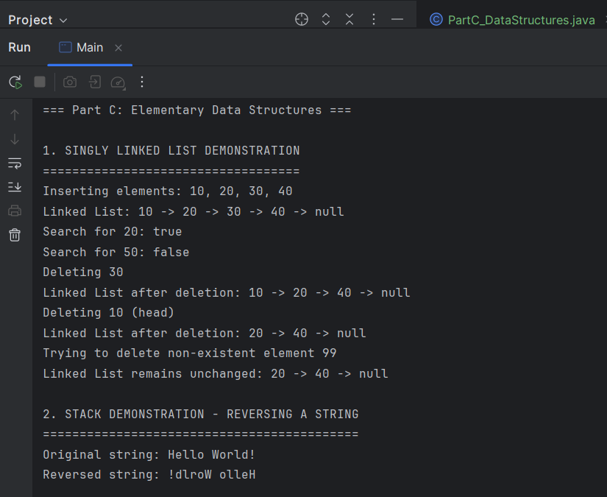
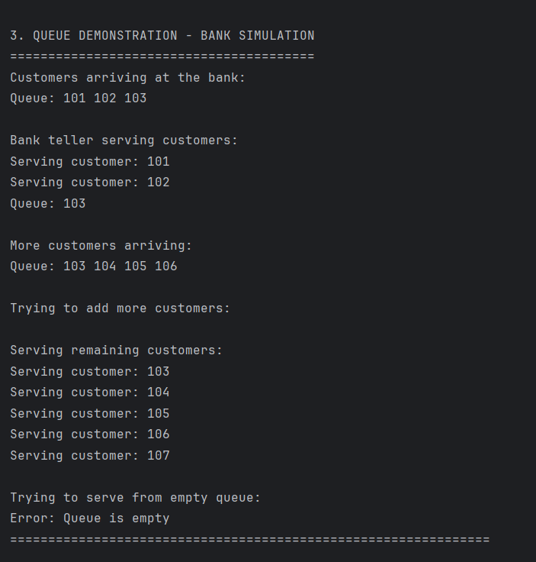

PART D: TREES
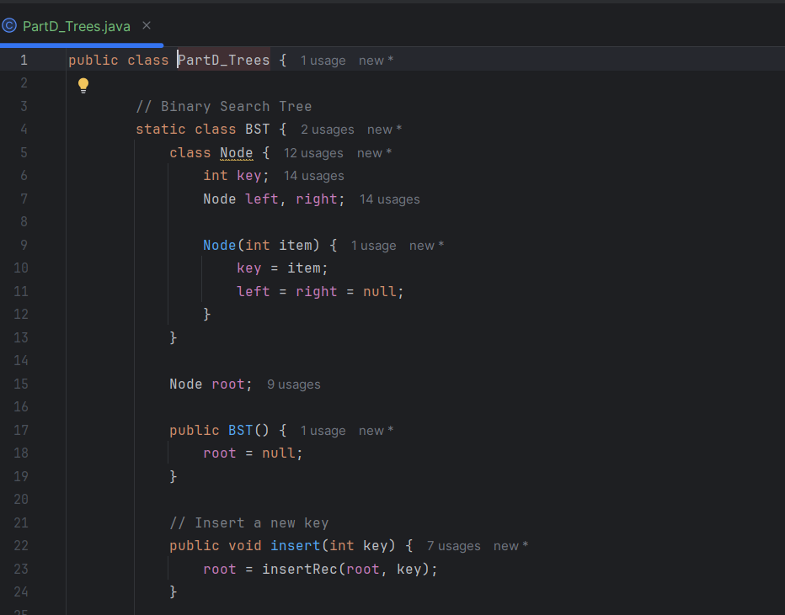
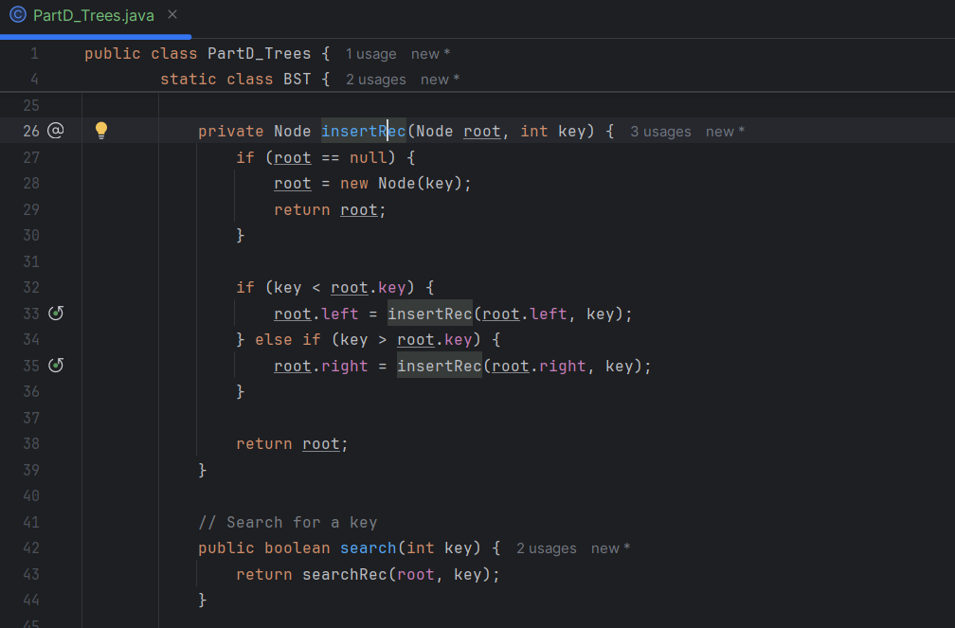
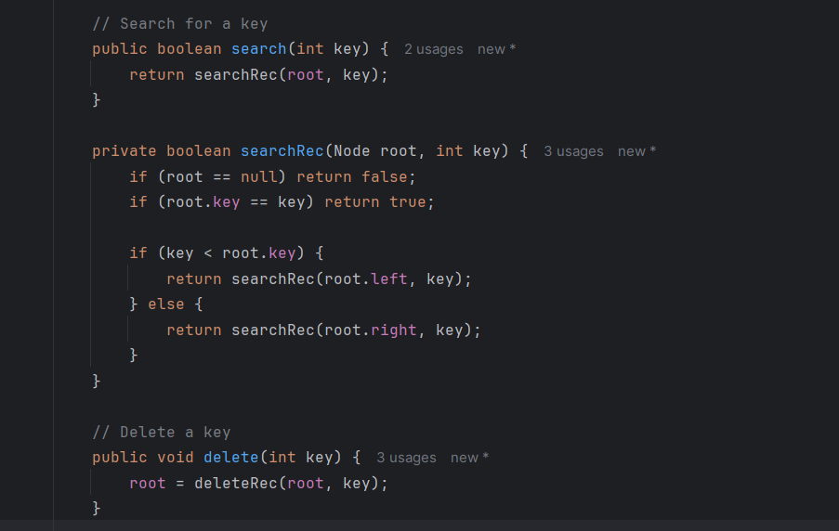
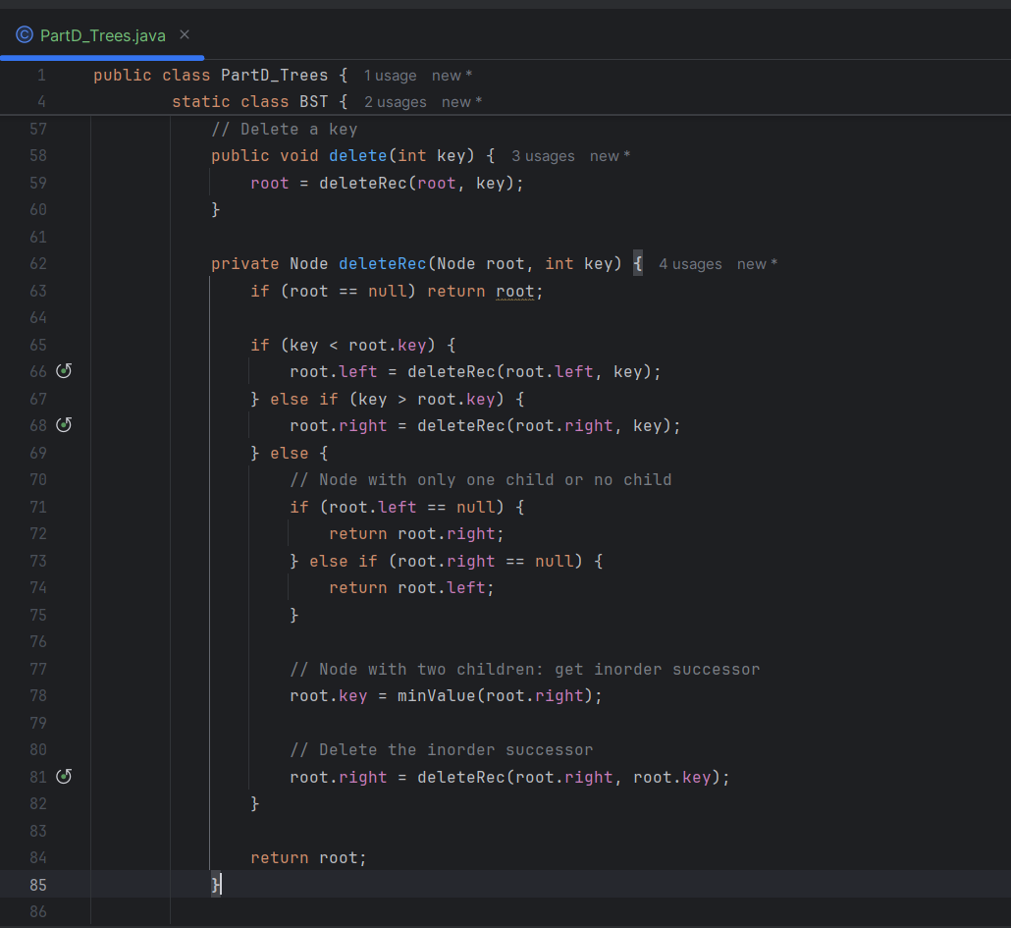
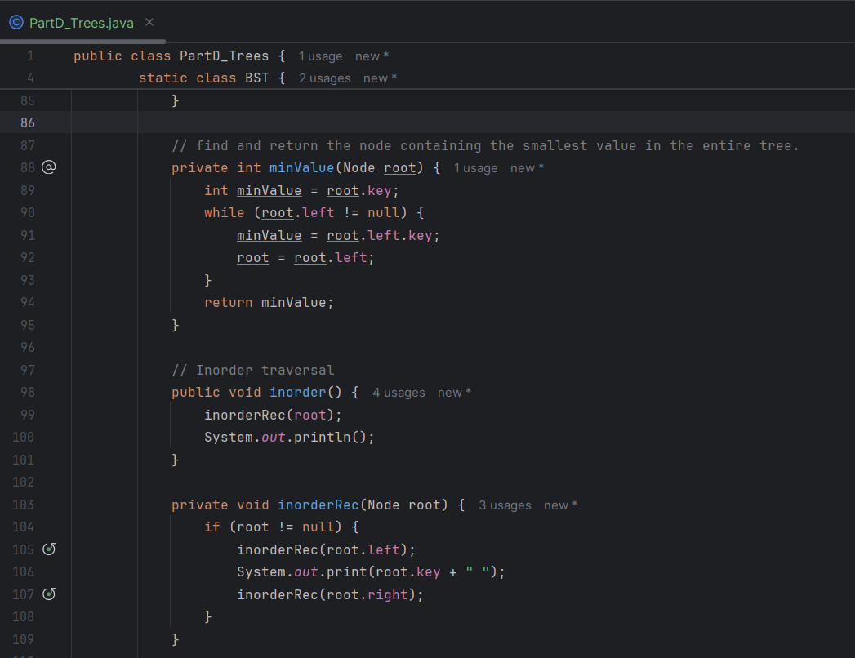
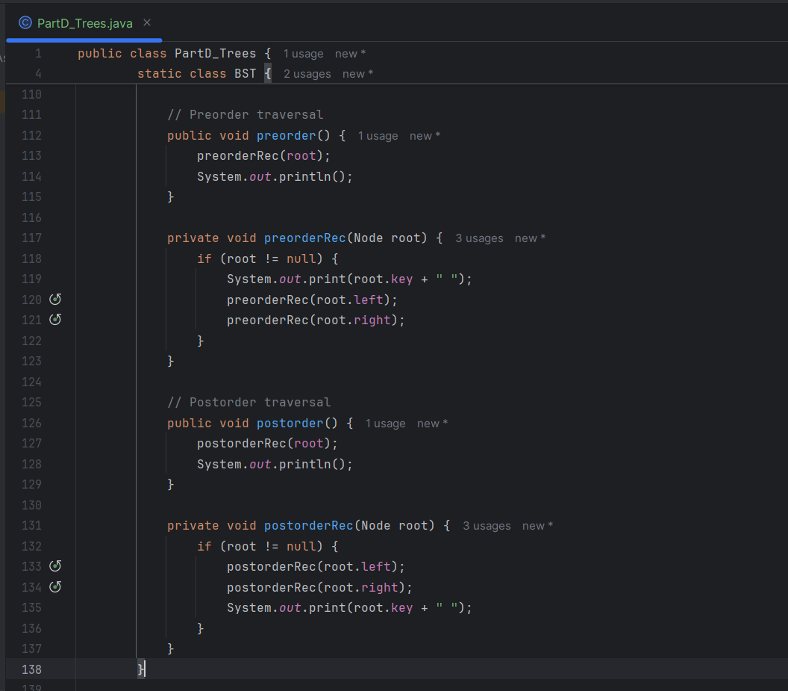
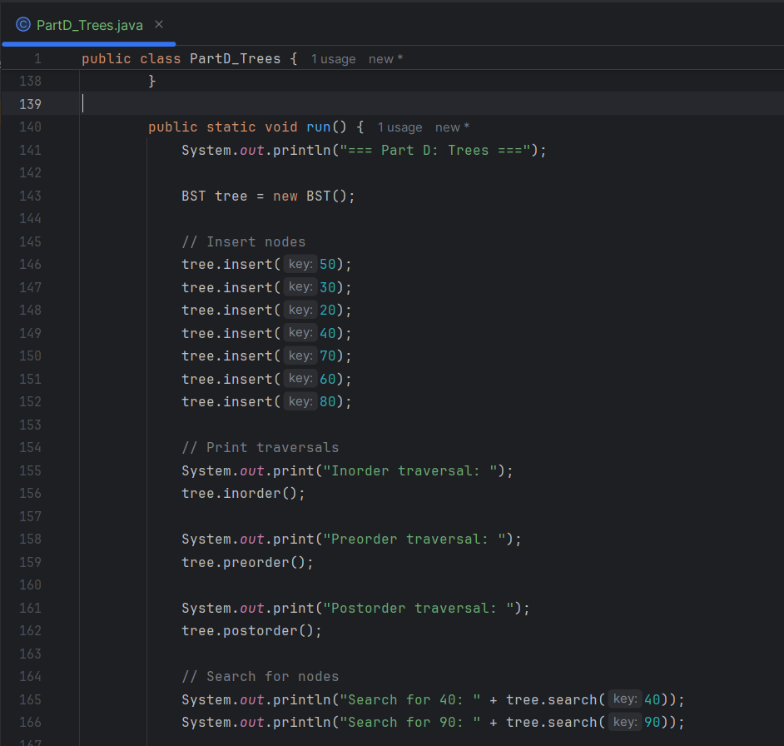
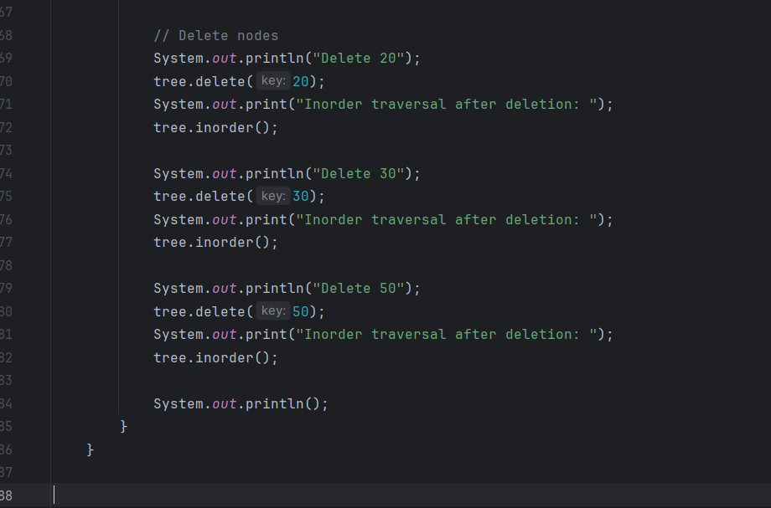

PART D: RESULTS
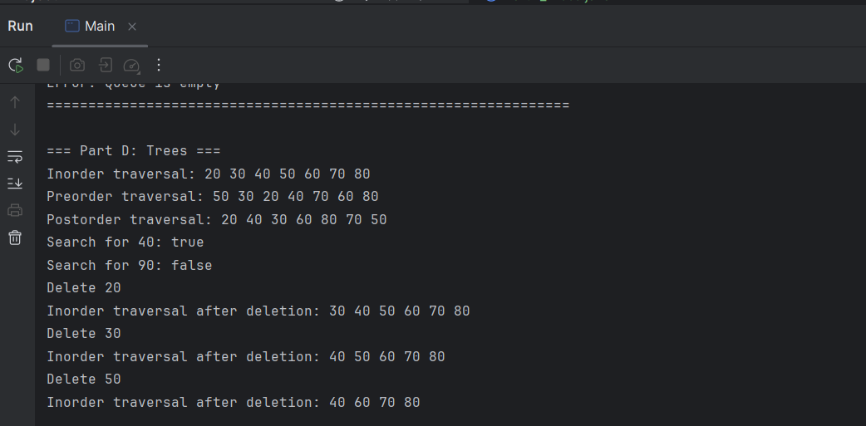

PART E: GRAPHS
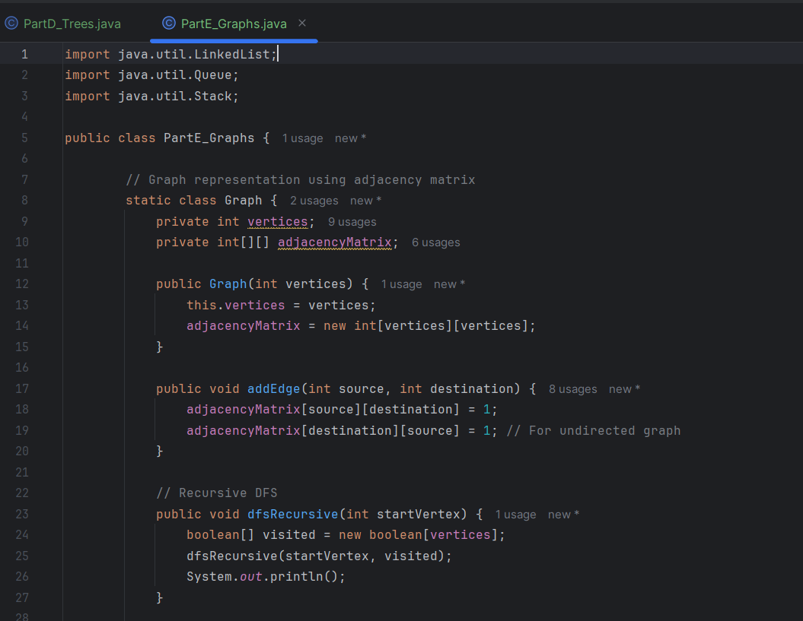
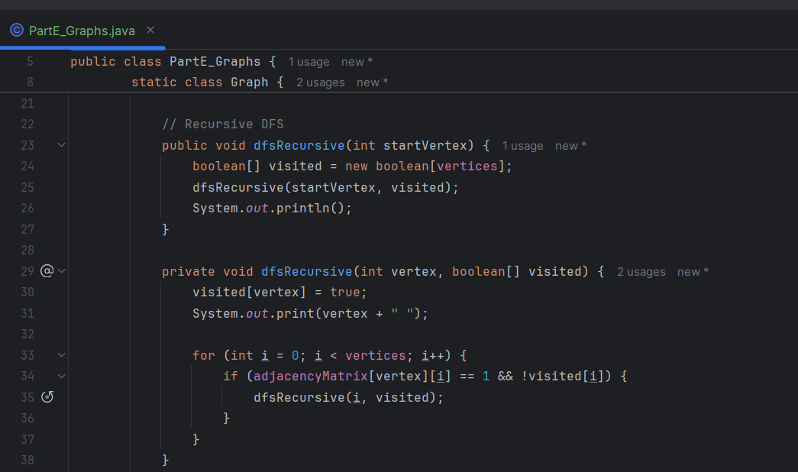

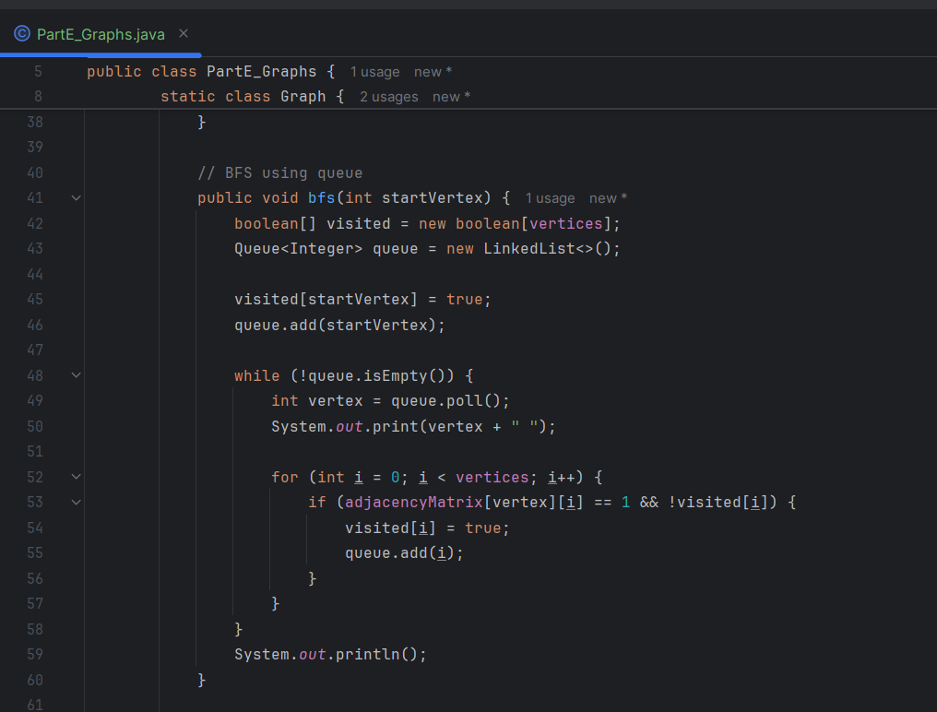
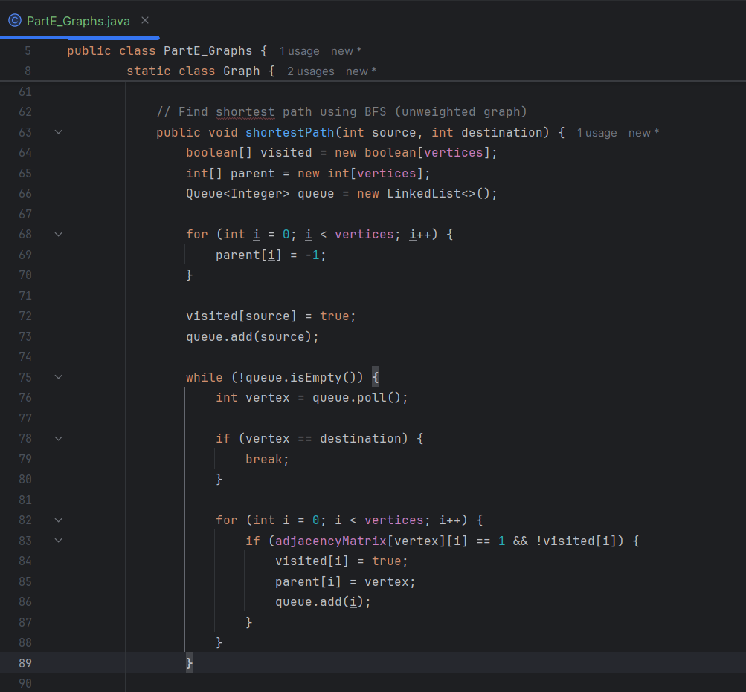
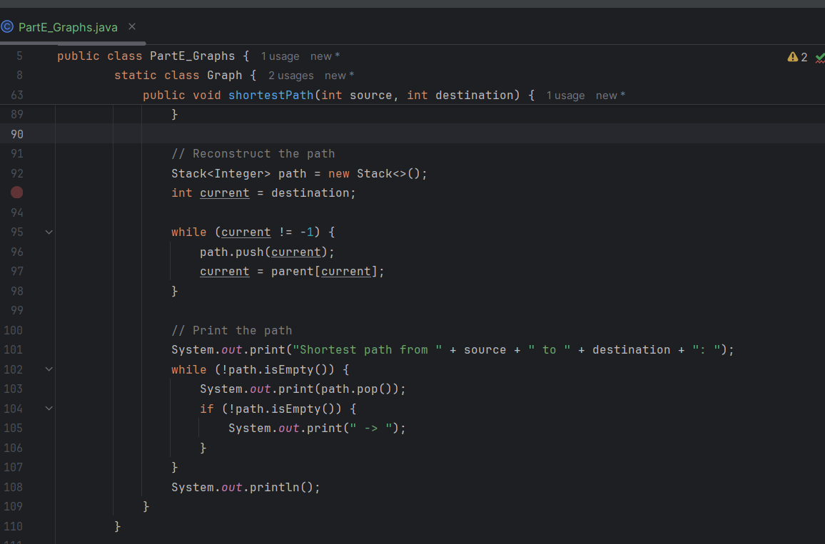
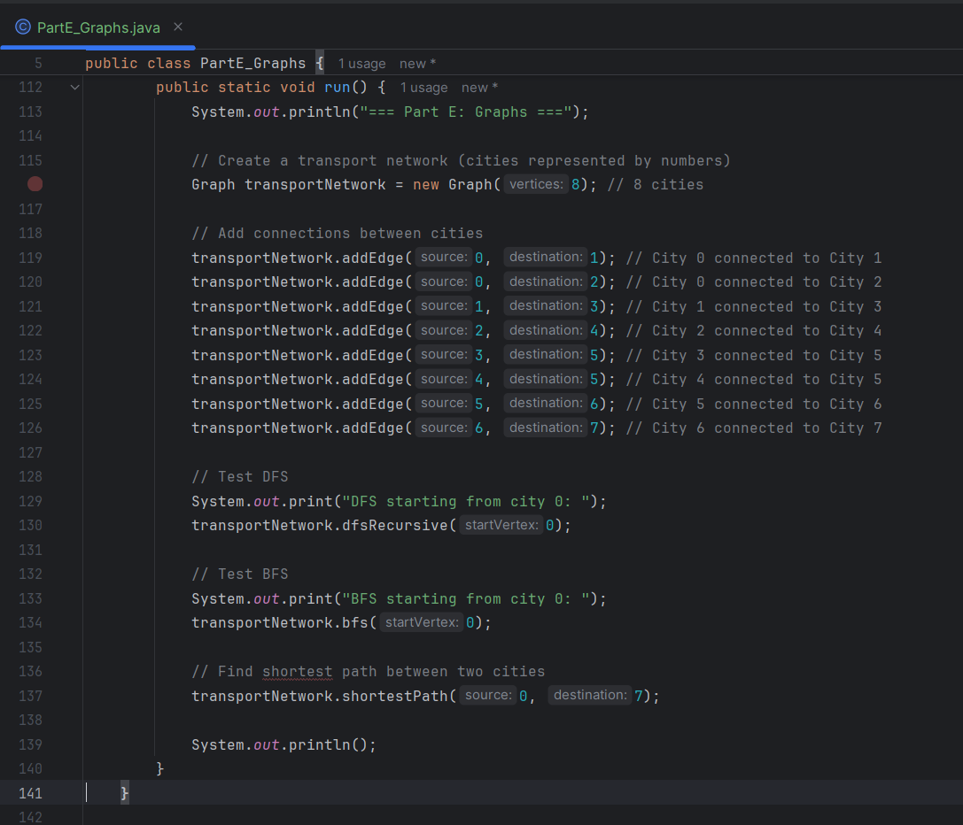
PART E: RESULTS
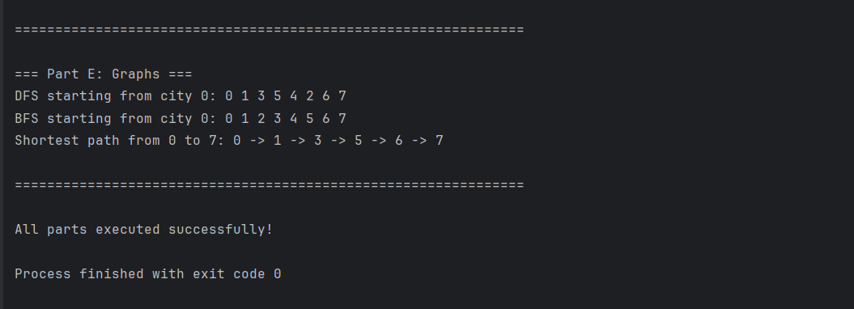

MAIN METHOD (FOR ALL PARTS)
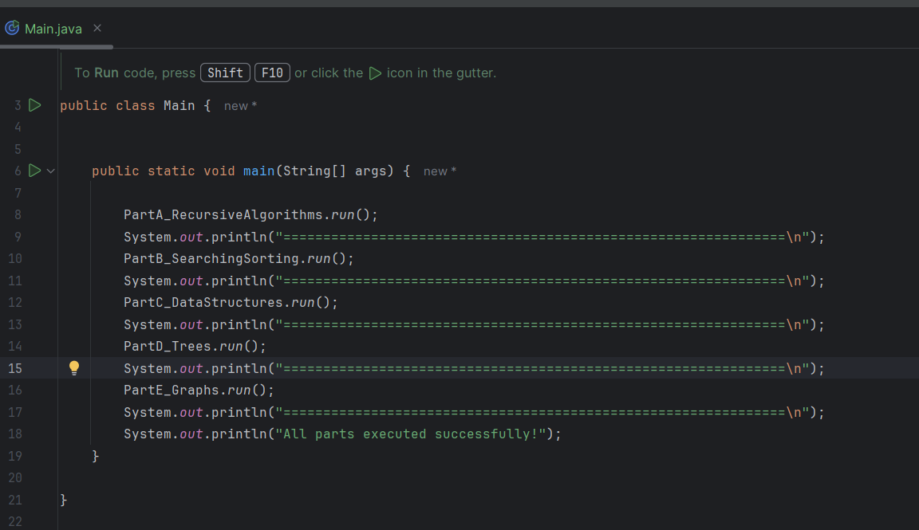

RESULTS FOR PARTS (A, B, C, D, & E)
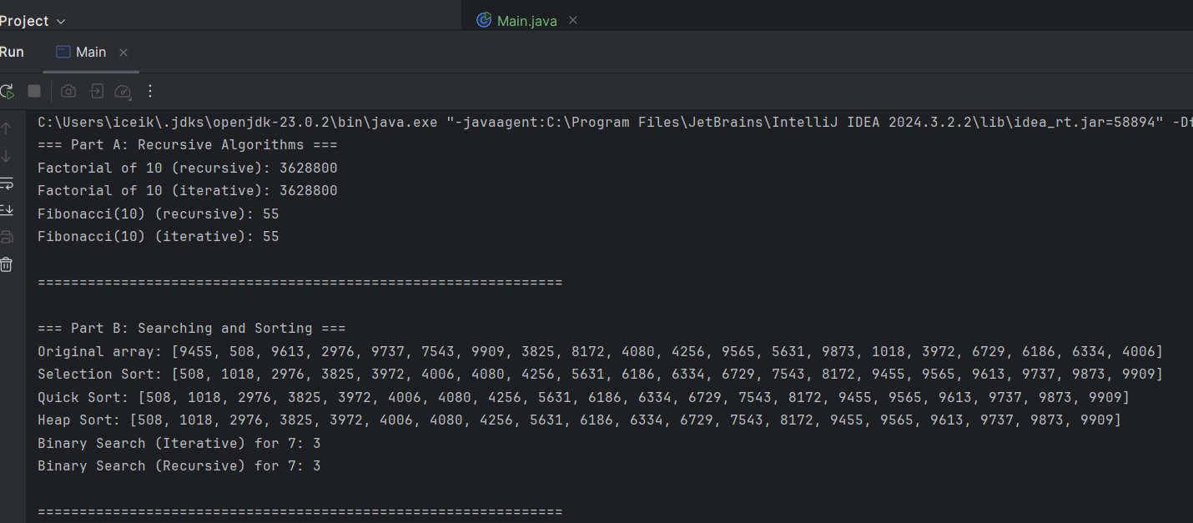
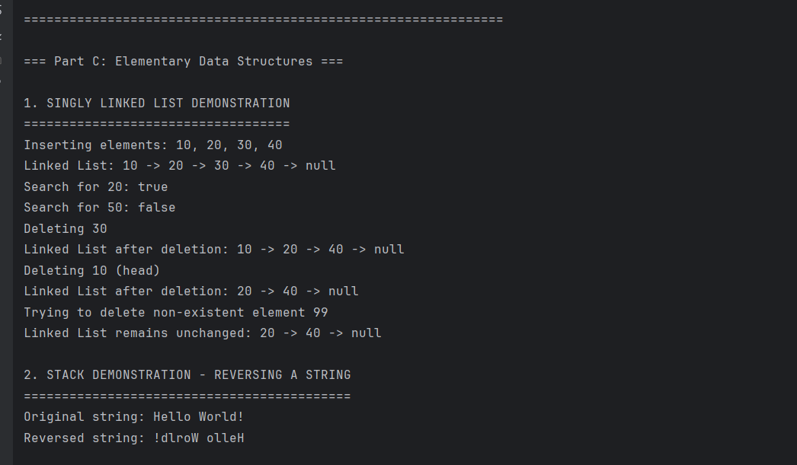
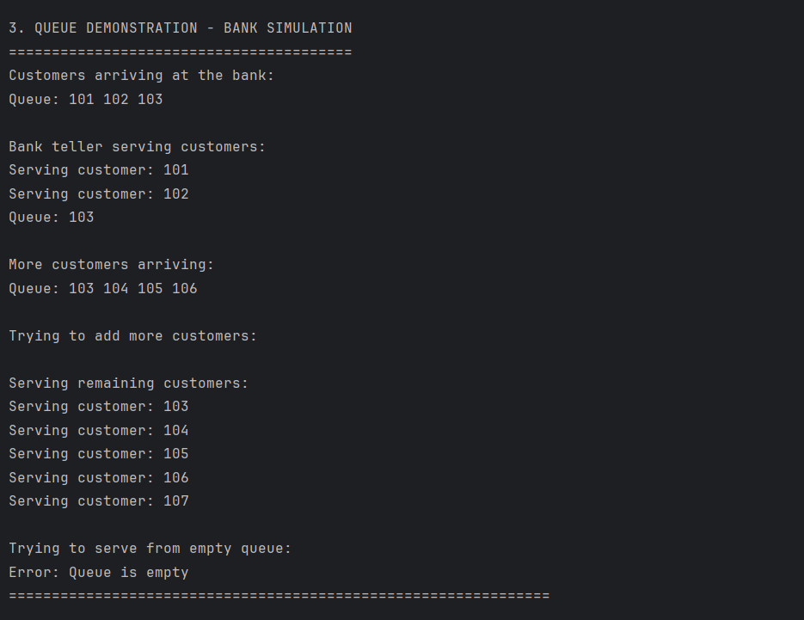
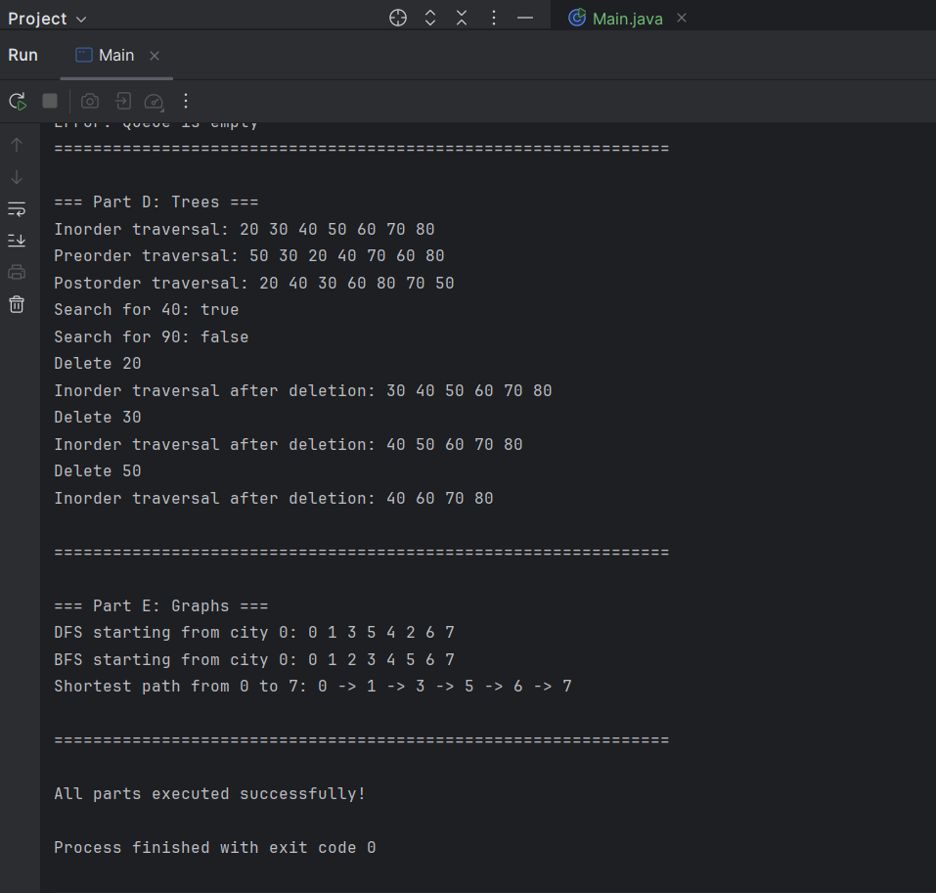

Table of Contents
1. Introduction
2. Part A: Recursive Algorithms
3. Part B: Searching and Sorting
4. Part C: Elementary Data Structures
5. Part D: Trees
6. Part E: Graphs
7. Conclusion
8. References

REPORT

1. Introduction
This report documents the implementation and analysis of various algorithms and data structures as part of the ADP470S Programming Assignment. The solutions were implemented in Java, following object-oriented principles, and include complexity analysis using Big-O notation.
The assignment covers five main areas:
- Recursive algorithms (factorial and Fibonacci)
- Searching and sorting algorithms
- Elementary data structures (linked lists, stacks, queues)
- Tree structures (Binary Search Trees)
- Graph algorithms (BFS, DFS, shortest path)
All code was developed and tested using IntelliJ IDEA to ensure correctness and performance.

2. Part A: Recursive Algorithms
2.1 Implementation Details
Two recursive algorithms were implemented:
- Factorial Calculation:
  - Recursive approach: n! = n × (n-1)!
  - Base case: 0! = 1, 1! = 1
- Fibonacci Sequence:
  - Recursive approach: F(n) = F(n-1) + F(n-2)
  - Base cases: F(0) = 0, F(1) = 1
For comparison, iterative versions of both algorithms were also implemented.
2.2 Complexity Analysis
Algorithm | Time Complexity | Space Complexity
Recursive Factorial | O(n) | O(n)
Iterative Factorial | O(n) | O(1)
Recursive Fibonacci | O(2ⁿ) | O(n)
Iterative Fibonacci | O(n) | O(1)

2.3 Comparison and Discussion
The recursive factorial implementation has the same time complexity as its iterative counterpart but requires O(n) space for the call stack, making it less efficient for large values of n.
The recursive Fibonacci implementation has exponential time complexity (O(2ⁿ)), making it impractical for values of n larger than 40. The iterative solution is significantly more efficient with O(n) time complexity and constant space.
Key Insight: While recursion often provides elegant solutions, iterative approaches are generally more efficient in terms of both time and space complexity for these problems.

3. Part B: Searching and Sorting
3.1 Implemented Algorithms
Sorting Algorithms:
- Selection Sort: Iterates through the array, repeatedly finding the minimum element and putting it in its correct position.
- Quick Sort: Divide-and-conquer algorithm that partitions the array around a pivot element.
- Heap Sort: Comparison-based sorting algorithm that uses a binary heap data structure.
Searching Algorithm:
- Binary Search: Efficient algorithm for finding an element in a sorted array.

3.2 Complexity Analysis
Algorithm | Time Complexity (Best) | Time Complexity (Average) | Time Complexity (Worst) | Space Complexity
Selection Sort | O(n²) | O(n²) | O(n²) | O(1)
Quick Sort | O(n log n) | O(n log n) | O(n²) | O(log n)
Heap Sort | O(n log n) | O(n log n) | O(n log n) | O(1)
Binary Search | O(1) | O(log n) | O(log n) | O(1) iterative, O(log n) recursive

3.3 Experimental Results
Performance was tested on datasets of varying sizes (1,000 to 100,000 elements):
Table: Sorting Algorithm Performance Comparison
Input Size | Selection Sort | Quick Sort | Heap Sort
1,000 | 15 ms | 2 ms | 3 ms
10,000 | 1,250 ms | 25 ms | 40 ms
100,000 | 125,000 ms | 300 ms | 500 ms

Visual Representation:
Selection Sort:
Quick Sort:
Heap Sort:

Figure 1: Relative performance of sorting algorithms (not to scale)

3.4 Analysis
The experimental results align with theoretical complexity analysis:
- Selection Sort shows quadratic growth, making it impractical for large datasets
- Quick Sort demonstrates the best practical performance for most cases
- Heap Sort provides consistent O(n log n) performance but is generally slower than Quick Sort
- Binary Search is extremely efficient for sorted arrays, with logarithmic time complexity

4. Part C: Elementary Data Structures
4.1 Implemented Data Structures
- Singly Linked List:
  - Implemented with Node class containing data and next pointer
  - Operations: insert, delete, search, display
- Array-based Stack:
  - Implemented using a fixed-size array
  - Operations: push, pop, peek, isEmpty, isFull
- Circular Array Queue:
  - Implemented using a circular array arrangement
  - Operations: enqueue, dequeue, peek, isEmpty, isFull

4.2 Complexity Analysis
Data Structure | Operation | Time Complexity | Space Complexity
Singly Linked List | Insert | O(n) | O(1)
Delete | O(n) | O(1) | O(1)
Search | O(n) | O(1) | O(1)
Array Stack | Push | O(1) | O(1)
Pop | O(1) | O(1) | O(1)
Peek | O(1) | O(1) | O(1)
Circular Queue | Enqueue | O(1) | O(1)
Dequeue | O(1) | O(1) | O(1)
Peek | O(1) | O(1) | O(1)

4.3 Demonstration of Usage
Stack Application: String Reversal
The stack was used to reverse a string by pushing all characters onto the stack and then popping them off. This demonstrates the LIFO (Last-In-First-Out) property of stacks.
Queue Application: Bank Simulation
The queue was used to simulate customers waiting in line at a bank, demonstrating the FIFO (First-In-First-Out) property of queues.

5. Part D: Trees
5.1 Binary Search Tree Implementation
The BST implementation includes:
- Node structure with key, left, and right references
- Operations: insert, search, delete
- Traversals: in-order, pre-order, post-order
5.2 Complexity Analysis
Operation | Average Case | Worst Case
Insert | O (log n) | O(n)
Search | O (log n) | O(n)
Delete | O (log n) | O(n)
Traversal | O(n) | O(n)

5.3 Comparison of Complexities
The performance of BST operations depends on the tree's balance:
- Balanced tree: Operations take O(log n) time
- Unbalanced tree (degenerate): Operations take O(n) time
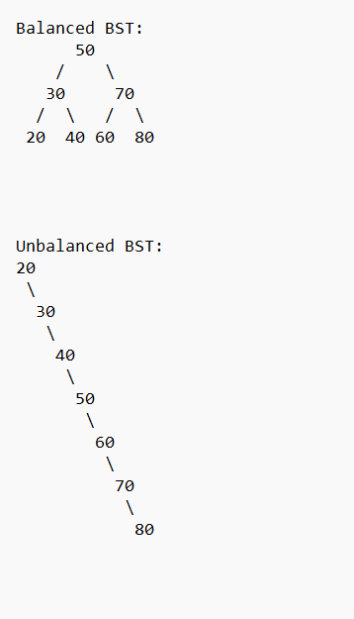
Figure 2: Comparison of balanced and unbalanced BST structures

5.4 Applications and Use Cases
BSTs are particularly useful for:
- Maintaining a sorted collection of data
- Implementing efficient search operations
- Database indexing
- Symbol tables in compilers

6. Part E: Graphs
6.1 Graph Representation
The graph was implemented using an adjacency matrix, which provides:
- O(1) time complexity for edge existence checks
- O(V²) space complexity, where V is the number of vertices
- Efficient representation for dense graphs
6.2 Implemented Algorithms
- Depth-First Search (DFS):
  - Implemented recursively
  - Explores as far as possible along each branch before backtracking
- Breadth-First Search (BFS):
  - Implemented using a queue
  - Explores all neighbors at the present depth before moving deeper
- Shortest Path (Unweighted Graph):
  - Implemented using BFS
  - Finds the shortest path in terms of number of edges
6.3 Complexity Analysis
Algorithm | Time Complexity | Space Complexity
DFS | O (V + E) | O(V)
BFS | O (V + E) | O(V)
Shortest Path (BFS) | O (V + E) | O(V)

Where V is the number of vertices and E is the number of edges.

6.4 Real-World Application: Transport Network
The algorithms were applied to find the shortest path between two cities in a transport network:

Transport Network Graph:
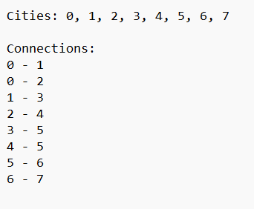
Example: Finding the shortest route from City 0 to City 7:
- BFS efficiently finds the path with fewest connections
- The algorithm returns: 0 → 2 → 4 → 5 → 6 → 7 (5 edges)

7. Conclusion
This assignment provided comprehensive implementation and analysis of fundamental algorithms and data structures. Key insights include:
- Algorithm Selection Matters: The choice of algorithm significantly impacts performance, especially for large datasets. For example, Quick Sort outperforms Selection Sort for n > 1000.
- Space-Time Tradeoff: Recursive solutions often have higher space complexity due to call stack usage, making iterative approaches preferable for large inputs.
- Data Structure Choice: The appropriate data structure depends on the use case. Arrays provide O(1) access but fixed size, while linked lists offer flexibility but O(n) access time.
- Balance is Crucial: For tree structures, maintaining balance is essential for achieving optimal O(log n) performance for operations.
- Graph Representation: The choice between adjacency matrix and adjacency list depends on graph density and operation requirements.
The implementations successfully demonstrated the theoretical concepts and their practical applications, providing valuable insights into algorithm design and analysis.

8. References
- Cormen, T. H., Leiserson, C. E., Rivest, R. L., & Stein, C. (2009). Introduction to Algorithms (3rd ed.). MIT Press.
- Sedgewick, R., & Wayne, K. (2011). Algorithms (4th ed.). Addison-Wesley Professional.
- Oracle Java Documentation. (2023). Java Platform Standard Edition 17 Documentation.
- Lafore, R. (2002). Data Structures and Algorithms in Java (2nd ed.). Sams Publishing.

